Assignment 1
HCI
9/8/03
Ron Price

Affordance: how well an entity portrays what its purpose/function is

Mapping: how well the functionality of the entity is mapped to the purpose/function of
the entity

Entity Portraying Good Affordance:

Sink:

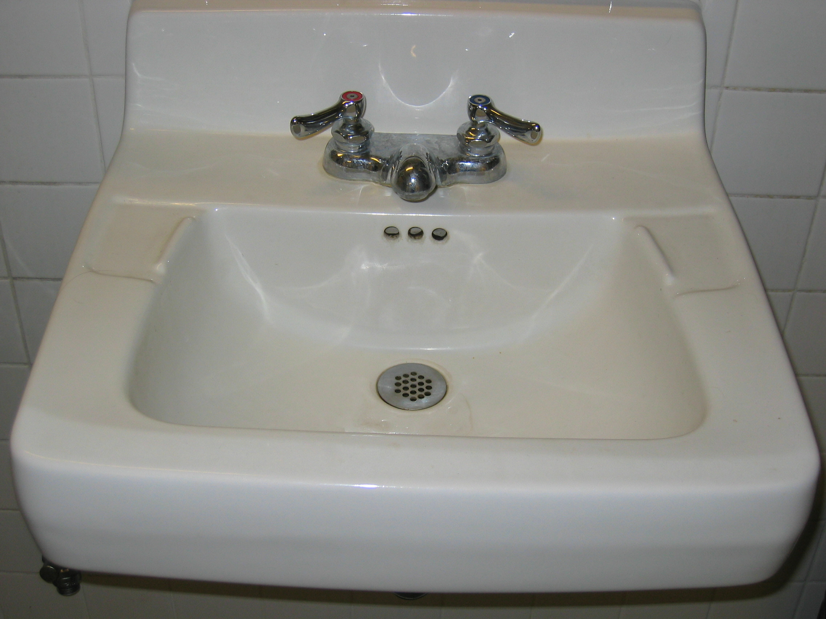

This sink has good affordance, because the knobs are color coded and both turn in a intuitive fashion.

Entity Portraying Poor Affordance:

Air Mouse:

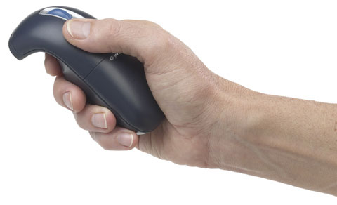
The air mouse exhibit poor affordance, because the term mouse may mislead a user to think “up” on the screen corresponds to pushing forward on a horizontal plane. Furthermore, more poor affordance is attributed to the unfamilliar grip and shape of this new mouse.

Entity Portraying Good Mapping:

Air Mouse:

The air mouse exhibits good mapping, because up on the screen corresponds to moving the air mouse up. The plane of the air mouse is parallel to the plan on the monitor unlike a conventional mouse- a vertical plane in both cases.

Entity Portraying Poor Mapping:

Sink:

This sink has poor mapping, because the knobs lead the user to believe she/he may obtain cold water, but cold water is impossible to access. Both knobs produce hot water; very inconvenient when the user want to brush his/her teeth.

